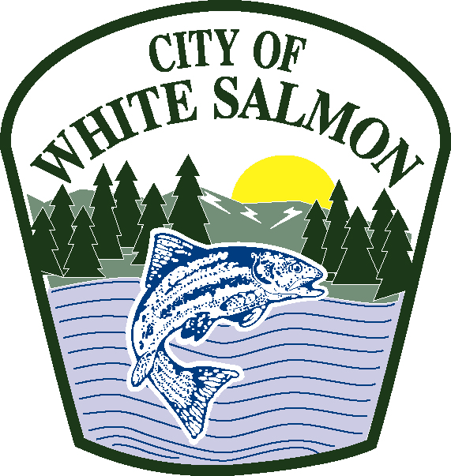

City of White Salmon
Office of City Hall

Request for Proposals
Certified Arborist – Oversight of Tree Maintenance and Removal

The City of White Salmon is seeking proposals from certified arborists to provide oversight of a city contractor hired to conduct tree maintenance and removal per industry standards. The Scope of Work for the tree maintenance and removal is attached.

Proposals shall be submitted to the City of White Salmon no later than October 31, 2019, 5:00 p.m. Proposals may be mailed to City of White Salmon, Attention: Jan Brending, PO Box 2139, White Salmon, WA 98672 (with envelope marked “RFP – Certified Arborist), dropped off at City Hall, 100 N. Main, White Salmon WA 98672 (marked RFP – Certified Arborist) or emailed to janb@ci.white-salmon.wa.us (include “RFP – Certified Arborist) in subject line. Proposals must be received no later than 5:00 p.m. October 31, 2019.

Proposals will be reviewed by the City of White Salmon Tree Board and a recommendation made to the City of White Salmon City Council based on the most qualified proposal.

If you have any questions regarding the RFP, please contact Jan Brending by email janb@ci.white-salmon.wa.us.

