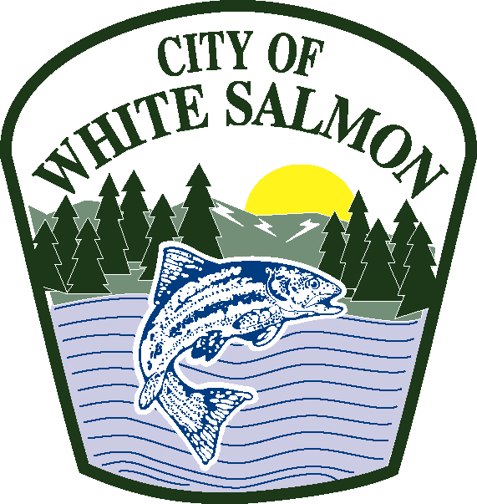

**White Salmon City Council Meeting – October 15, 2018 – 3:00 p.m.**

**Fire Hall, 119 NE Church Avenue**

**SPECIAL COUNCIL MEETING**

**1. Call to Order**

**2. Roll Call**

**3. Washington State Auditor’s – Exit Conference**

**4. Adjournment**